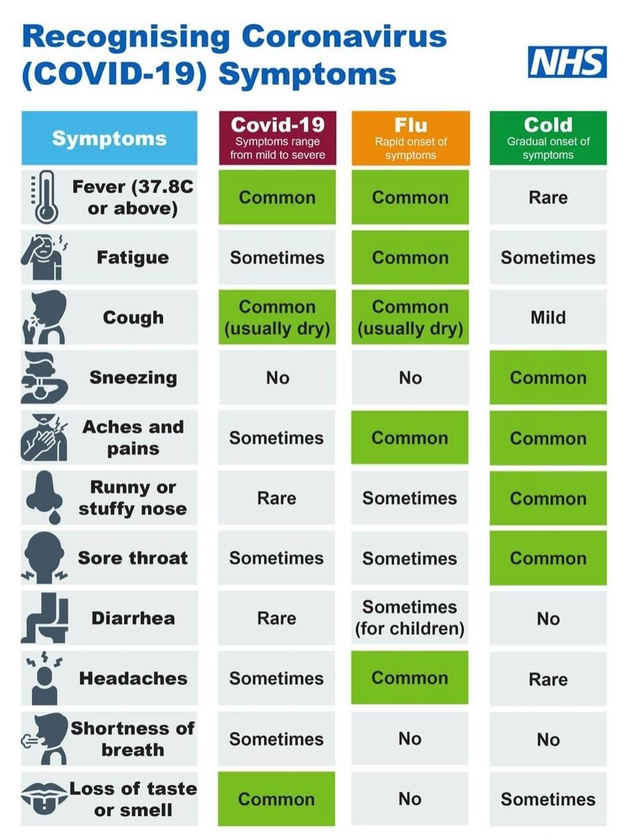

**Swimming**

Please remember that swimming is compulsory and is part of the curriculum. Please remember to send your child with their swim wear every Tuesday.

**Term Dates**

October Half Term: Monday 19th October-Monday 2nd November

Christmas Holidays: Monday 21st December- Monday 4th January 2021

February Half Term: Mon 15th – Friday 19th February 2021

**Secondary School Places**

A reminder that our year six parents need to complete their child’s secondary school place online. Please see the link below.

<https://www.nottinghamcity.gov.uk/information-for-residents/education-and-schools/school-admissions/transfer-to-secondary-school-in-year-7/>

The deadline for submitting the application is 31st October 2020. If you need any support with this, please contact school.

**Tier Two Lockdown**

As you may have heard in the news, Nottinghamshire is now on Tier Two lockdown. This came in to place on Wednesday 14th October 2020. Tier two lockdown means we have adhere to the following regulations:

* Mixing of households indoors is not allowed. This includes visiting close friends and family unless they are your support bubble.
* You can meet up to six people outdoors only
* Bars and restaurants will continue to have a curfew of 10pm closure.
* Social distancing to continue
* If you visit another area outside of Nottingham, you cannot share accommodation with people outside of your own household. This include family parties and weddings.

As half term approaches, we ask all parents to follow the restrictions.

**Parking**

The Local Authority visited the school twice last week to monitor the parking situation on Norton Street and they were shocked at their findings. They have now referred this on and will possibly bring in significant road changes outside of school. We have been asking for such a long time now for parents to drive and park responsibly for the safety of both parents and children. Please remember to not park on the yellow zigzags or the double yellow lines.

Have a lovely half term

**Amanda Dawson**

**Headteacher**