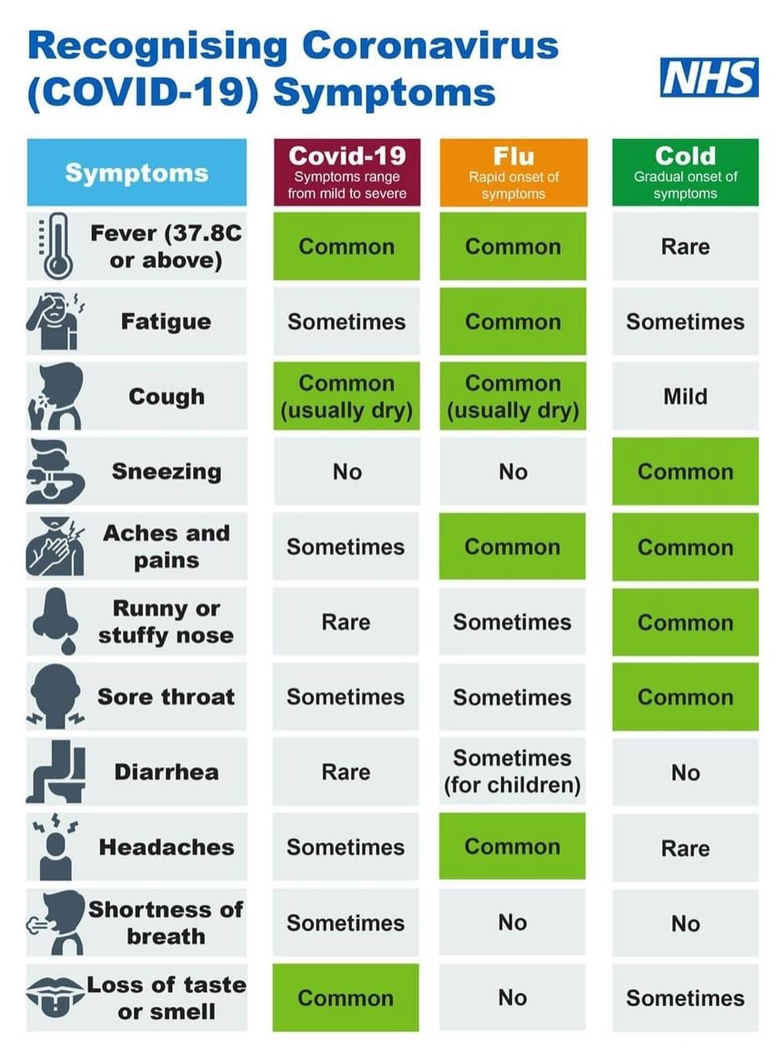

**Swimming**

Swimming has now stopped due to the Government placing us in a full lockdown. We will hope to start back in September!

**Dinner Money Debts**

We are now in the processing of referring debts to Nottingham City Council for parents who have still not cleared their child’s dinner money account. Anyone who still owes money will be informed that their child will have to make alterative lunchtime arrangements until the debt is paid off. They will no longer be able to stay for a school dinner.

**Thank You!**

We would like to thank all of our nursery parents for queuing so nicely. All week you have queued sensibly and patiently. We appreciate your support during this difficult time!

**Thank You!**

**Mellers Food Bank**

We know that these are difficult times at the moment both emotionally but also financially. We are still running our food bank here at Mellers. If you are struggling and need the food bank, please contact Miss Cannop or Miss Bramley and they can arrange a parcel for your family throughout lockdown. This is strictly confidential and we consider the foods your family eat. We also have limited baby items.

**Lockdown**

As you may be aware, England is now in full lockdown again from Thursday 5th November. The Government have stated that schools must remain open. Please continue to send your child every day. This is compulsory for all school aged children. Please follow the link for more guidance.

https://www.gov.uk/guidance/new-national-restrictions-from-5-november

**Parent Courses**

Miss Cannop is in contact with colleges regarding some online maths and English courses for parents. If this is something you are interested in, please get in contact with Miss Cannop straight away.

Have a lovely weekend

**Amanda Dawson**

**Headteacher**