**Government Announcement**

The Government announced that from Monday 8th March, schools will re-open to all children. The drop off and pick up arrangements will be exactly as they were before Christmas. We are so excited to welcome everyone back to Mellers!

Can we remind parents to continue to socially distance and wear a face covering when at the gate? If you need to see the office staff, you will also need to wear a face covering before entering the building.

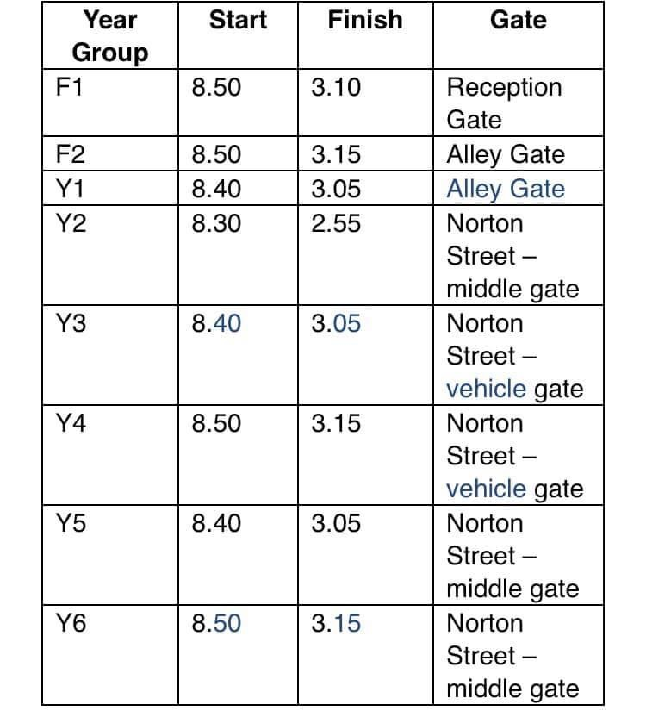

**Dates For Your Diary**

Here are a few dates for your diary:

* Monday 8th March School reopens to all children
* Thursday 1st April: last day of spring term
* Friday 2nd April: Good Friday Bank Holiday
* Monday 5th April: Easter Monday Bank Holiday
* 6th April- 16th April: Easter holiday
* Monday 19th April: first day back at school
* Monday 3rd May: May Day Bank Holiday
* Monday 31st May: Spring Bank holiday

**School Meals**

Our school kitchen has had to close this week due to a staff member testing positive for COVID. As the kitchen staff don’t have direct, close contact with the children, this didn’t affect any of our bubbles, just the kitchen team. This meant that we were only able to provide sandwiches, which is why we asked those parents that pay for school dinners to provide their own packed lunch for their child, as this is cheaper for you. The school kitchen will be open as normal from Monday 2nd March and hot meals will be served to all the children that are currently in school.

**Dinner Money**

Your child’s dinner money account must be up to date before they return to school on the Monday 8th March. If your child is year 3 and you are unable to clear the balance in full, please send your child with a packed lunch every day until the account has been cleared.

Packed lunches must not contain fizzy drinks or sweets (including chocolate bars), and please don’t send your child with cold takeaway food in their lunch box. Packed lunches must be health and nutritious.

**Teams**

Well done to all of our pupils (and parents of course!) who have committed to online learning! Mrs Buttress did some research to find out exactly how many of our pupils are regularly accessing our live lessons, and we’re so pleased to let you know that over 90% of pupils are joining us every day for the Teams lessons! You will find this really helps you on your return to school in March. You have been so dedicated!



Have a lovely weekend!

**Amanda Dawson**

**Headteacher**