**F2 Sponsored Hop!**

Our F2 classes are having a sponsored hop day! This is to help raise money for plants and gardening resources in foundation. The date will be confirmed next week but if you would like to donate anything towards this, you can donate a minimum of £1.00 on the Gateway app. Alternatively you can donate cash directly to the F2 staff. Any donations are appreciated.



**September 2021 Nursery Places**



**Dinner Money**

Please stay up to date with your child’s lunch money account. Anyone with arrears over £10.00 will have their school meals stopped. For children in year 3 and above, your child can bring a packed lunch from home. If you are facing financial difficulties, please contact Miss Bramley to arrange a payment plan.

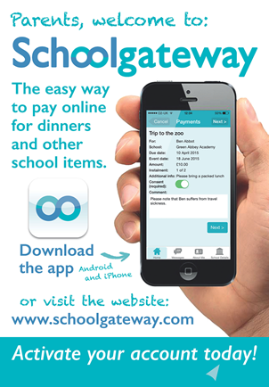

**Kidzklub**

Please remember that Kidzklub finishes at 5.30pm. If you are late collecting your child you will be charged £1 per minute.

**Bank Holiday**

Remember that we have a long weekend this week! On Monday 3rd May, it is a bank holiday so there will be no school. We will return to school on Tuesday 4th May.

Have a lovely long weekend!

**Amanda Dawson**

**Headteacher**