**Appointments**

We have had a lot of children coming and going throughout the school day for appointments and various other reasons. If you can try to make any medical appointments for the beginning or the end of the school day unless it is an emergency. Please take a copy of the appointment letter for your child’s attendance records.

**Start and Finish Timings**

Children are arriving to school late. This disrupts their class as well as their learning. It can also have a negative impact for them for the rest of the day. Please arrive on time.

|  |  |  |  |
| --- | --- | --- | --- |
| **Year Group** | **Start time** | **Finish time** | **Gate** |
| **F1** | 8.50 | 3.10 | F1 GATE |
| **F2 N.CASTLE** | 8.40 | 3.05 | ALLEY GATE |
| **F2 W.HALL** | 8.50 | 3.15 | ALLEY GATE |
| **YEAR 1** | 8.30 | 2.55 | TOP GATE |
| **YEAR 2** | 8.30 | 2.55 | MIDDLE GATE |
| **YEAR 3** | 8.40 | 3.05 | TOP GATE |
| **YEAR 4** | 8.50 | 3.15 | TOP GATE |
| **YEAR 5** | 8.40 | 3.05 | MIDDLE GATE |
| **YEAR 6** | 8.50 | 3.15 | MIDDLE GATE |

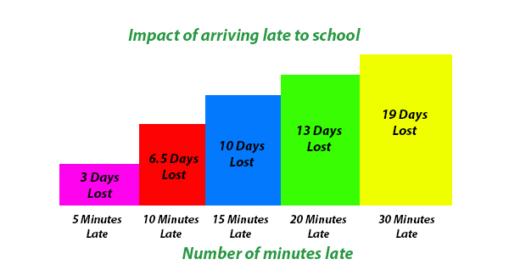

**China Trip**

We have had an amazing response for the China trip next year. The list is now full. If any places become available, we will let parents know straight away.

**Covid-19**

Although things are slowly starting to return to normal, Covid is still very much present and we all need to do our bit to keep everyone safe.

If your child has loss of taste or smell, a cough or temperature, you must keep them at home along with any of their siblings. If your child does have symptoms, we will request for the child to be tested with a **PCR test** (this is where you book online and have to go to a testing site). Your child will not be able to return to school until you have a negative PCR test result. Please follow the link below for more information and to book a free test.

<https://www.gov.uk/get-coronavirus-test>

**Norton Street**

We’ve had another near miss outside school due to our parents irresponsible parking. Please do not park on double yellow lines or the yellow zigzags. Can we also remind parents not to mount the pavements to ensure our children can walk on them safely.

Can we remind Parents that if you have an issue with another child in school then please speak to your childs class teacher.

Have a lovely weekend!

**Amanda Dawson**

**Headteacher**