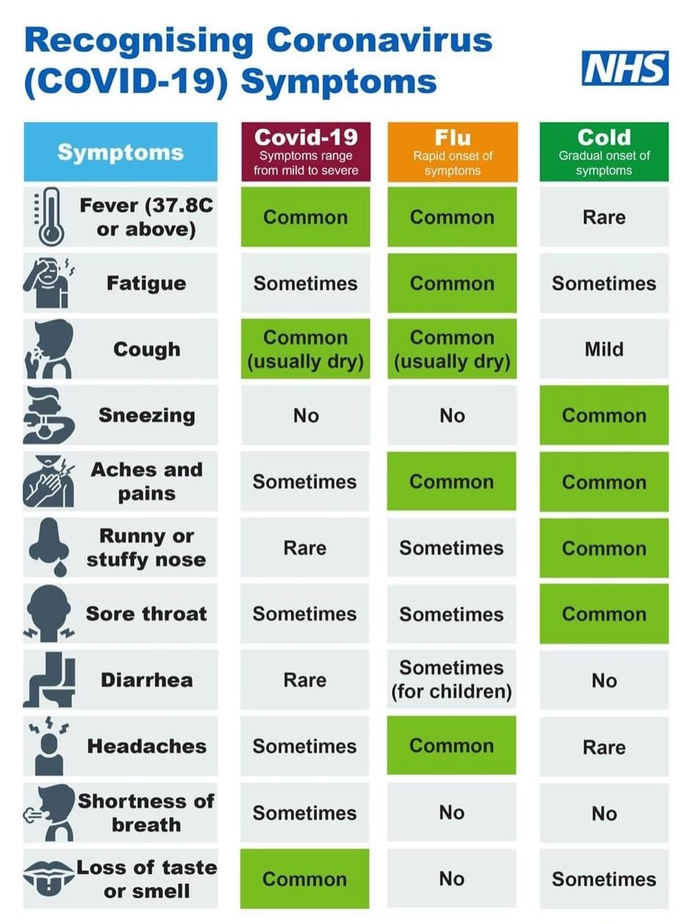

**Red Ted**

Please remember to read with your child at least three times a week. This will help them get their Red Ted reward!

**Thank you! Thank You! Thank You!**

Again, we would like to thank all of our parents for their continuous support throughout this year. Attendance has been outstanding! You have put your faith and trust into school and we are forever thankful! Mellers is so lucky to have such caring and supportive parents.

**Christmas is Coming!**

This year has been extremely hard for us all. We are currently working on how we can have our usual Christmas events virtually. Keep a look out on our newsletters in the coming weeks for more information. We **WILL** get into the Christmas spirit!!

[](https://www.google.com/url?sa=i&url=https://www.history.com/topics/christmas/history-of-christmas&psig=AOvVaw04RkGgbX3IyrTdEvE5_HFu&ust=1605781344279000&source=images&cd=vfe&ved=0CAIQjRxqFwoTCICp7-bvi-0CFQAAAAAdAAAAABAQ)

**Abuse to Staff**

We have a zero-tolerance policy towards swearing and threats of violence towards any member of staff. Anyone giving verbal abuse to office or teaching staff will be asked to leave the premises immediately. This will then be followed up with a letter and a possible ban.



**Cashless Office**

A polite reminder that we are now a cashless office. This means we are no longer able to accept cash when you buy uniform or pay for school dinners. Please pay by the school gateway app or by card. Thank you.

Have a lovely weekend

**Amanda Dawson**

**Headteacher**