**Dinner Money**

If you owe any dinner money for your child, please can you clear your account. We are now stopping all school meals if they are not being paid for. Your child will have to either go home for dinner time or stay for a packed lunch. If you are facing financial difficulties, please speak to a member of the school office.

**Dates For Your Diary**

Here are a few dates for your diary:

**Thursday 10th December**:

Christmas concert on Teams (the video will be shared with parents afterwards)

**Wednesday 16th December**:

Christmas party day. Bring your party clothes in a bag for the afternoon! (please do not bring any food, drink or snacks this year)

**Thursday 17th December**:

Christmas dinner

Christmas pantomime on demand

Christmas jumper day

Last day for all nursery children

**Friday 18th December**:

X-Factor and 1pm finish

Christmas jumper day (again!)

**Nottingham Music Hub**

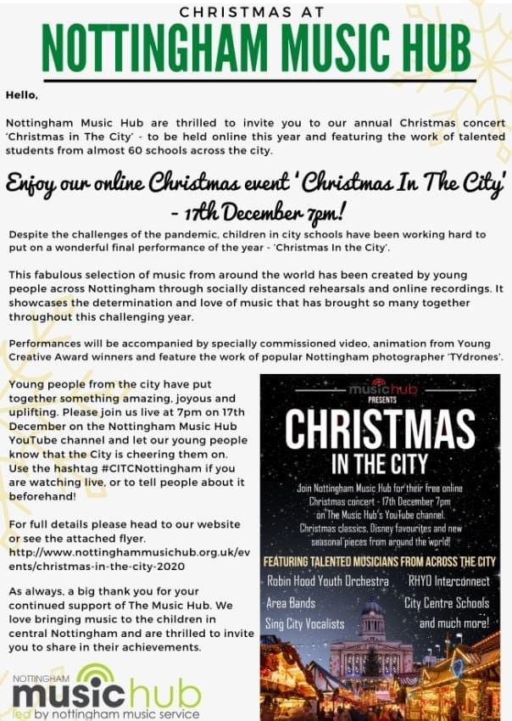

**Free Christmas Plays**

Follow the link below to get in the Christmas spirit with 12 tiny plays!

<https://www.flyhighstories.co.uk/>



**Last Day of Term**

Friday 18th December is the last day of term. School will finish at **1pm prompt!** Please collect your child from their usual gate. Nursery children will finish on **Thursday 17th December** at the usual time of 3.10pm.

Have a lovely weekend

**Amanda Dawson**

**Headteacher**